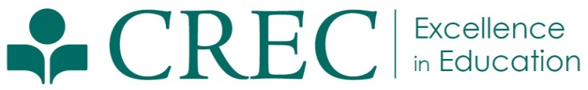
Press Release

FOR IMMEDIATE RELEASE  October 17, 2013 | Julia Winer  Assistant Director of Communications  (860) 509-3666  jwiner@crec.org
CREC Arts Academy Student Recognized by National Merit Scholarship Program
(Hartford, CT) Justine Collins of Canton, a senior at the CREC Greater Hartford Academy of the Arts was named a Commended Student in the 2014 National Merit Scholarship program. Commended students are recognized for their exceptional academic promise. Collins is among the top five percent of the more than 1.5 million students who entered the competition for 2014.

“I am so thankful to everyone who has helped me along the road to achievement,” shared Justine Collins. “I'm eternally grateful for the opportunity to learn and excel, and I'm so happy to receive this honor."

Students entering the competition must take the 2012 Preliminary SAT/National Merit Scholarship Qualifying Test. “The young men and women being named Commended Students have demonstrated outstanding potential for academic success,” commented a spokesperson for NMSC in a press release. “These students represent a valuable national resource; recognizing their accomplishments, as well as the key role their schools play in their academic development, is vital to the advancement of educational excellence in our nation.”

CREC’s Greater Hartford Academy of the Arts is an Interdistrict magnet school enrolling students in PreK through Grade 12. More information about CREC or CREC’s award-winning Magnet Schools is available at www.crec.org.

###
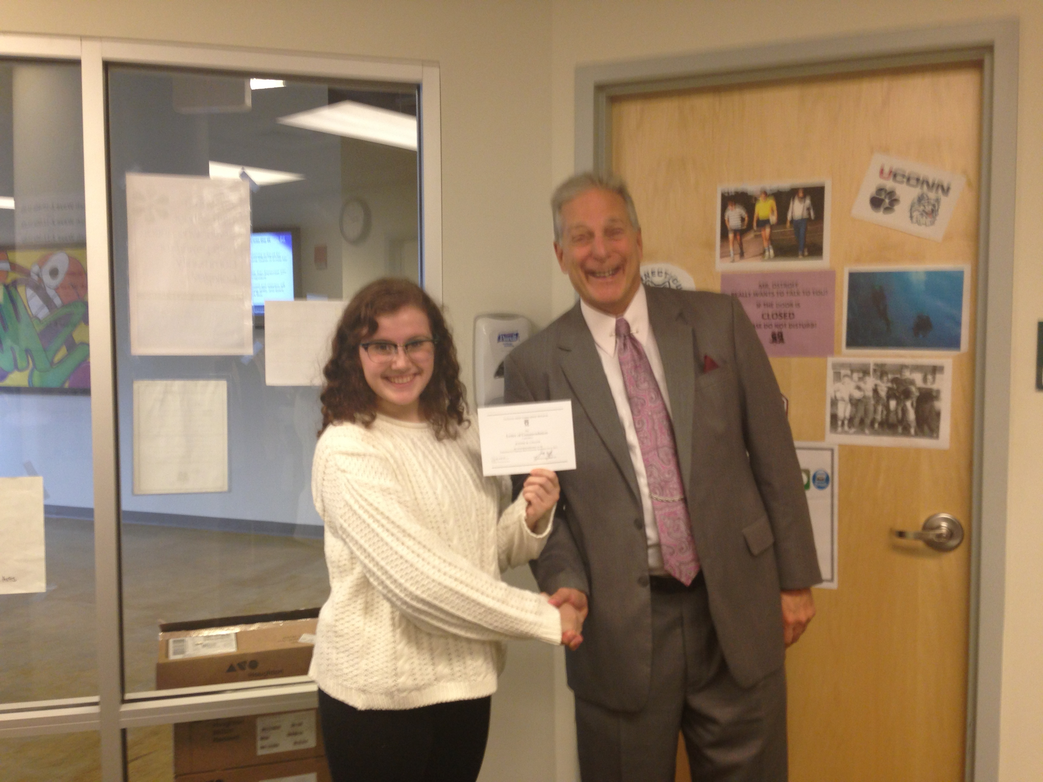
Justine Collins receives her commendation letter from the National Merit Scholarship Program with Jeff Ostroff, Principal of the CREC Greater Hartford Academy of the Arts High School.

The CREC Greater Hartford Academy of the Arts is an interdistrict magnet high school that offers both full-day and half-day programs for students throughout Greater Hartford. For more than 25 years, the Academy has focused on developing the fullest academic and artistic potential in all students, encouraging them to be creative, engaged citizens, and preparing them to pursue careers in the arts. Art classes are offered in creative writing, dance, inter arts, theater, technical theater, music (vocal and instrumental), musical theater and visual arts.

The Capitol Region Education Council was established in 1966. Working with and for its member districts, CREC has developed a wide array of cost-effective and high-quality programs and services to meet the educational needs of children and adults in the region. CREC regularly serves 36 towns in Greater Hartford, offering more than 120 programs to more than 150,000 students annually. CREC manages more than 35 facilities throughout the area, including 18 interdistrict magnet schools. More information about CREC or CREC’s award-winning Magnet Schools is available at www.crec.org.

