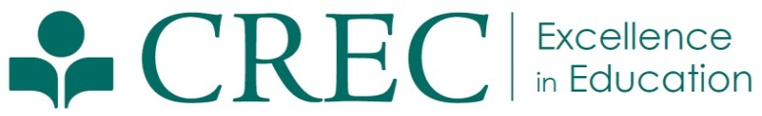
Press Release

FOR IMMEDIATE RELEASE  April 7, 2015 | Amanda Falcone  Communications Specialist  (860) 509-3663  afalcone@crec.org
CREC Student Athletes Raise Money for Cancer Research
(Hartford, CT) CREC’s high school and middle school student athletes recently raised $4,931 for the V Foundation. The money will be used to further cancer research.

The V Foundation was founded in 1994 after Jim Valvano, a college basketball coach, died from cancer at the age of 46. The foundation has awarded more than $130 million to more than 120 facilities throughout the United States, and 100 percent of its direct donations go toward funding cancer research and related programs.

CREC’s student athletes raised the money for the V Foundation in January and February by asking for donations from family and friends. They also held dress down days for both staff and students, sold athletic gear online, and ConnectiCare made a generous donation.

Ultimately, more than 500 CREC students participated in fundraising efforts. The students attend CREC Two Rivers Magnet Middle School, CREC Two Rivers Magnet High School, the CREC Metropolitan Learning Center for Global and International Studies, the CREC Medical Professions and Teacher Preparation Academy, the CREC Academy of Aerospace and Engineering Middle School, the CREC Academy of Engineering High School, and the CREC Public Safety Academy.

CREC’s student athletes chose to raise money for the V Foundation because February was Coaches vs. Cancer month. In addition to raising money, students at each participating school were asked to consider the impact of cancer on a more personal level. Students discussed how cancer has affected their loved ones.

At CREC, community service is a cornerstone of the athletics program. Through participation in community service activities, student athletes learn how they can help others—a sense of responsibility that CREC hopes will stay with them throughout their lives.

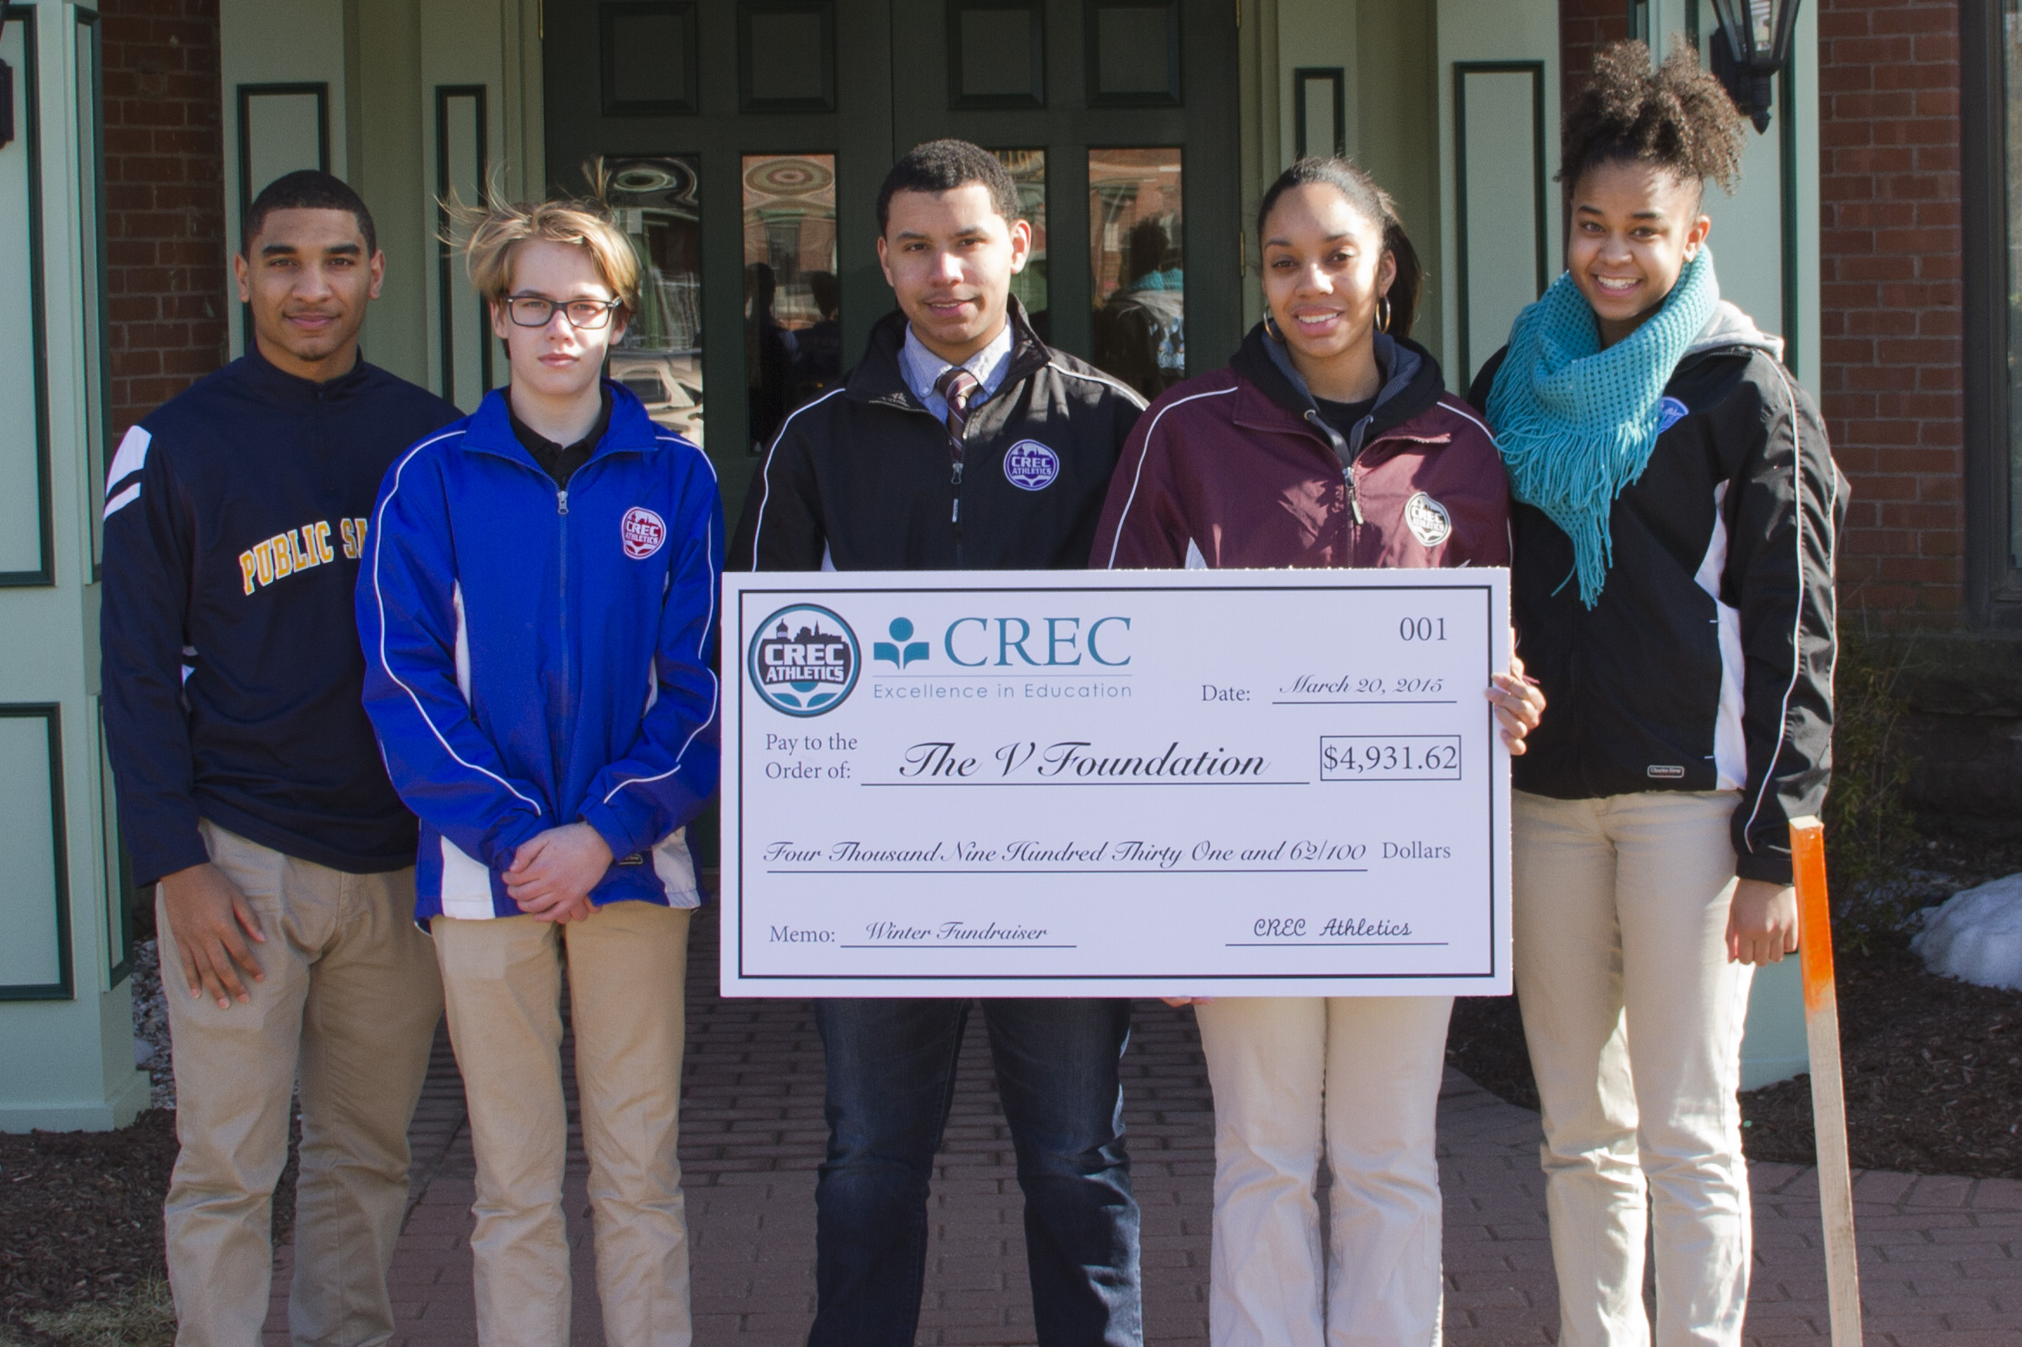

###

The Capitol Region Education Council was established in 1966. Working with and for its member districts, CREC has developed a wide array of cost-effective and high-quality programs and services to meet the educational needs of children and adults in the region. CREC brings nearly five decades of experience in education, regional collaboration, and operations to provide innovative strategies and products that address the changing needs of school districts and their students, corporations, non-profits, and individual professions. CREC regularly serves 36 towns in Greater Hartford, offering more than 120 programs to more than 150,000 students annually. CREC manages more than 35 facilities throughout the area, including 19 interdistrict magnet schools. More information about CREC and CREC’s award-winning schools is available at www.crec.org.

